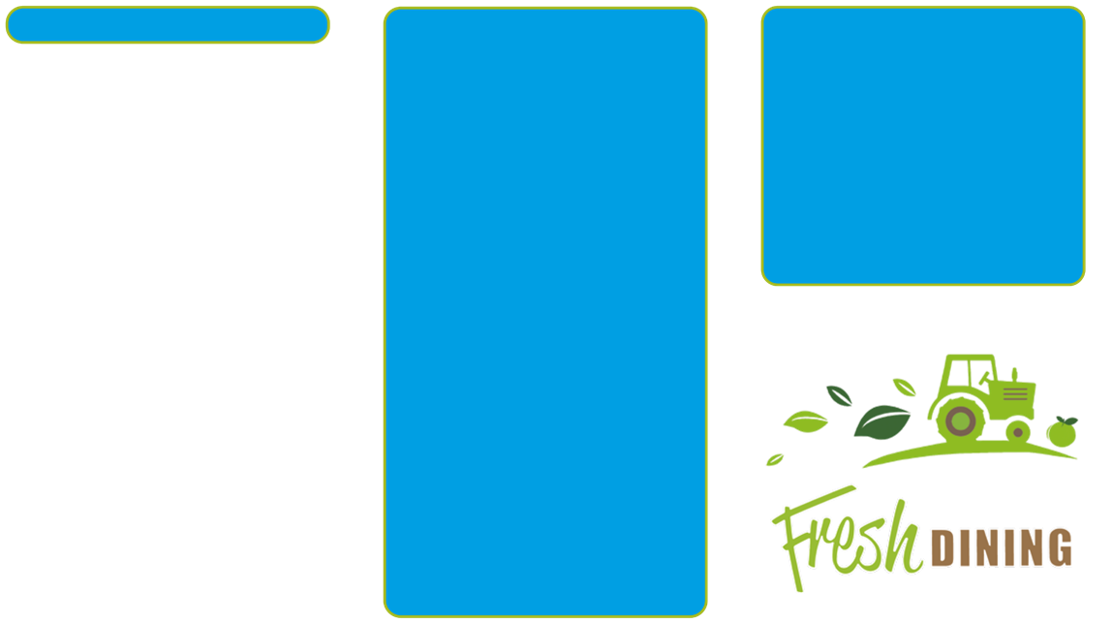
Free School Meals

Your child may be able to get free school meals if you get any of the following:
- Income Support
- income-based Jobseeker’s Allowance
- income-related Employment and Support Allowance
- support under Part VI of the Immigration and Asylum Act 1999
- the guaranteed element of Pension Credit
- Child Tax Credit (provided you’re not also entitled to Working Tax Credit and have an annual gross income of no more than £16,190)
- Working Tax Credit run-on - paid for 4 weeks after you stop qualifying for Working Tax Credit
- Universal Credit - if you apply on or after 1 April 2018 your household income must be less than
£7,400 a year (after tax and not including any benefits you get)
- Children who get paid these benefits directly, instead of through a parent or guardian, can also get free school meals.
Your child may also get free school meals if you get any of these benefits and your child is both:
- younger than the compulsory age for starting school
- in full-time education
If your child is eligible for free school meals, they’ll remain eligible until they finish the phase of schooling (primary or secondary) they’re in on 31 March 2022.

Infant free school meals in England
Your child will be able to get free school meals if they’re in a government-funded school and in:
- reception class
- year 1
- year 2
Tell your local authority if you also get any of the
qualifying benefits. Your child’s school can get extra funding if you do.

www.gov.uk/apply-free-school-meals

We serve balanced and nutritious food.
- 75% of meals are freshly prepared.
- 50% of produce is locally sourced.
- All eggs are free range.
- All fish used on our menus are Marine Stewardship Certified (MSC).
- We do not add salt to any of our meals.
- We use Belton organic cheese.
- Every Friday an assortment of fresh fruit and yoghurt is the only pudding option.
- All puddings are made using reduced sugar recipes and fresh fruit is available daily.
- Our menus meet the Food for Life Silver standard.
- The menu may change to reflect seasonal fruit and vegetables.

Allergens and Special Diets
Details of allergens for each Shire Services’ recipe are listed in our allergy guidance packs. Please contact the school to arrange to meet the catering manager
to discuss any dietary requirements you have.

Shire Services HEAD OFFICE
Shropshire Food Enterprise Centre, Battlefield Enterprise Park, Shrewsbury, SY1 3TG.

Tel: 01743 250250
e-mail: shire.services@shropshire.gov.uk website: www.shropshire.gov.uk/shire.services
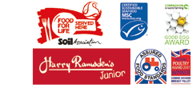
St Thomas & St Anne’s CE Primary School

Menu
September 2021 - July 2022

You can follow us on Facebook as “Shire Services” and Twitter as ‘Shropschoolmeal’

Education catering is our passion

Week

Commencing
Balanced and nutritious, freshly prepared school meals
20/09/2021  11/10/2021  08/11/2021  29/11/2021  03/01/2022  24/01/2022  14/02/2022  14/03/2022  04/04/2022  09/05/2022  06/06/2022  27/06/2022  18/07/2022 | Week 1 | MONDAY  Pork & Carrot Meatballs  All served with Penne Pasta,  Broccoli & Sweetcorn  Chocolate or Vanilla Muffin, Fruit Salad or Yoghurt | TUESDAY  Selection of Fish  All served with Garlic & Herb Wedges, Peas & Baked Beans  Cheese & Crackers, Vanilla  Ice-cream, Fruit Salad or Yoghurt | WEDNESDAY  Roast Beef with Yorkshire Pudding  & Gravy  All served with Roast Potatoes & Mash, Carrots, Broccoli & Cauliflower  Selection of Cookies, Fruit Salad or Yoghurt | THURSDAY  Breaded Chicken Breast Steak  & Noodles  All served with Sweet & Sour  Sauce, Green Beans & Sweetcorn  Toffee Cake & Custard, Fruit Salad  or Yoghurt | FRIDAY  Pizza (v) (with a selection of toppings & chips)  Served with Baked Beans  & Peas  ‘Fruity Friday’
06/09/2021  27/09/2021  18/10/2021  15/11/2021  06/12/2021  10/01/2022  31/01/2022  28/02/2022  21/03/2022  25/04/2022  16/05/2022  13/06/2022  04/07/2022 | Week 2 | MONDAY  Chicken Tikka Masala (with brown  & white rice & naan bread)  Served with Sweetcorn & Peas  Chocolate & Vanilla Mousse, Fruit Salad or Yoghurt | TUESDAY  Pork Sausages  All served with Chips or Jacket Potato, Baked Beans & Broccoli  Cheese & Crackers, Vanilla  Ice-cream (with toffee sauce),  Fruit Salad or Yoghurt | WEDNESDAY  Roast Chicken & Gravy  All served with Roast Potatoes & Mash, Carrots, Cabbage & Leek & Sweet Potato Bake  Selection of Cookies, Fruit Salad or Yoghurt | THURSDAY  Selection of Fish  All served with Baby Potatoes, Baked Beans & Peas  Chocolate Sponge & Chocolate Sauce, Fruit Salad or Yoghurt | FRIDAY  Pizza (with a selection of toppings)  All served with Sweetcorn  & Green Beans  ‘Fruity Friday’
13/09/2021  04/10/2021  01/11/2021  22/11/2021  13/12/2021  17/01/2022  07/02/2022  07/03/2022  28/03/2022  02/05/2022  23/05/2022  20/06/2022  11/07/2022 | Week 3 | MONDAY  Beef Burger  Served in a bun with a selection of fillings: onion, cheese & ketchup, with Baked Beans & Sweetcorn  Chocolate or Vanilla Cupcakes,  Fruit Salad or Yoghurt | TUESDAY  Cottage Pie  All served with Green Beans & Carrots  Mini Doughnuts, Fruit Salad or Yoghurt | WEDNESDAY  Roast Pork with Apple Sauce  & Gravy  All served with Roast Potatoes  & Mash, Carrots, Broccoli & Cauliflower Cheese  Selection of Cookies, Cheese & Crackers, Fruit Salad & Yoghurt | THURSDAY  Selection of Fish  All served with Chips or Noodles, Peas & Baked Beans  Ginger & Orange Sponge & Custard, Fruit Salad or Yoghurt | FRIDAY  Pizza (v) (with a selection of toppings & jacket wedges)  Served with Sweetcorn & Baked Beans  ‘Fruity Friday’
Available Daily: Freshly-made bread. Fruity Friday: A selection of fruit platter, fruit salad, fruit jelly, yoghurt & mango sorbet
Selection of Fish: Will be a combination of - battered pollock, fish cake, fish fingers, seaside fish fillet, pollock bites, pollock fillet
A Vegetarian Option is available on request – please give 2 days notice to allow for ordering
Food Allergen & Intolerance Information: Before ordering speak to our staff about your requirements. The menu may vary on promotional days.

