British
Values

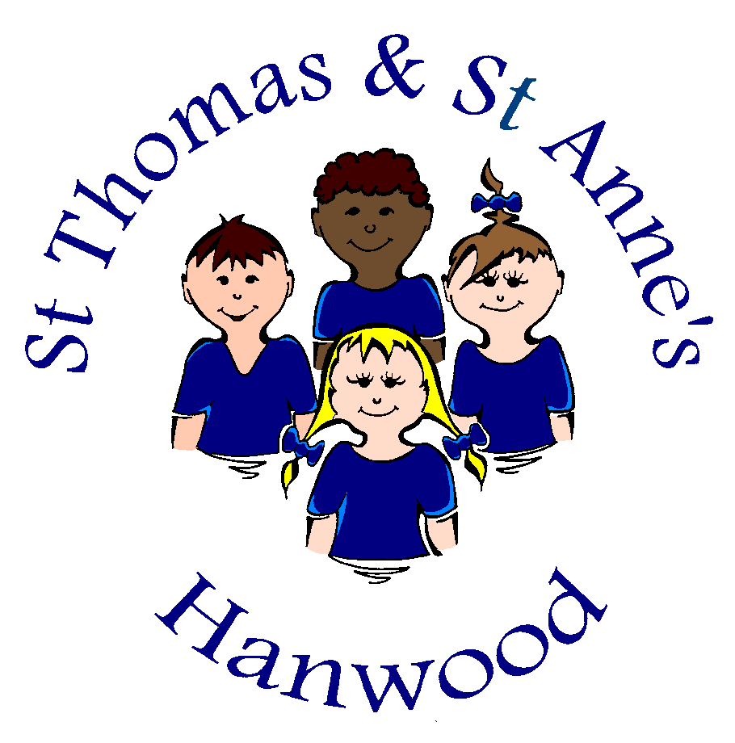

2021-22

British Values

The definition of British Values was outlined in the 2011 Prevent Strategy and has recently been reiterated by the Government.
St Thomas and St Anne’s strives to reinforce these values in the following ways:

Democracy
- ‘Pupil voice’ is actively encouraged here at St Thomas and St Anne’s. We encourage children to share their ideas and views regularly.
- We have a proactive School Council and House system where house captains act as a conduit between the children that they represent and the staff and governors. Each year House and Vice Captains are elected from nominated candidates from across Year 5/6. School Council representatives are also selected to represent all other year groups across the school. Each class elects a representative and in addition a Chair, Vice-Chair and Secretary from Years 5 and 6. They meet at least half termly and discuss a wide variety of issues. They take issues to their class for discussion and feedback ideas to the School Council from the rest of the pupil body.
- All children are able to give feedback to staff either informally or more formally such as questionnaires.
- Children also have the opportunity to talk to Governors when they are in school for Open Days or as part of their Link Governor visits or roles as volunteers within school. They are able to share their views, which in turn inform Governors of issues that are important to them.
- All children are involved in developing Class Rules at the beginning of each year, establishing a code of conduct by which all class members should act by throughout the year.

The Rule of Law
- The importance of laws is highlighted through the constant reinforcement of school rules throughout the school day, including assemblies. Children are taught the value and reasons behind laws, that they govern and protect us, the responsibilities that this involves and the consequences when laws or rules are broken. This may be exemplified by our school rules, rewards and sanctions which are referred to regularly and consistently upheld.
- Visits from authorities such as the Police and Fire Service aid reinforcement of this message. Such representatives may come into school from time to time, including during our Annual Health and Safety Week each autumn Term. We have a very good relationship with our local Community Support Officer who has a regular presence in school and around our village.

Individual Liberty
- Children are actively encouraged to make decisions and choices, knowing that they are in a safe and supportive environment. They are encouraged to know, understand and exercise their rights and personal freedoms and advise how to exercise these safely. For example through our E-safety and PSHE lessons. It may be that they choose a learning style that they prefer, select how they will record their learning or participate in one of our many extra-curricular clubs for example.

Mutual Respect
- As a Church of England school, mutual respect is at the heart of our values. Children learn that their behaviours have an effect on their own rights and those of others. All members of the school community treat each other with respect. Positive relationships are clearly evident between pupils, between pupils and staff and between staff. Everyone at St Thomas and St Anne’s is part of the team, all have a role to play and are respected for their contribution to the school community as a whole.

Tolerance of those of different faiths and beliefs
- Our school is not situated in a culturally diverse area; therefore we place great emphasis on promoting diversity with the children. This is addressed through RE and Collective Worship, where other faiths and cultures are explored. Our PSHE teaching also reinforces this. Each year the children learn about a world faith alongside their learning of Christianity. This includes Judaism, Sikhism, Hinduism, Buddhism and Islam. Members of different faiths and religions are encouraged to share their knowledge to enhance learning within classes and the school.

At St Thomas and Anne’s we will actively challenge children, staff or parents expressing opinions contrary to fundamental British Values, including those expressing ‘extremist’ views.

Preventing radicalisation and extremism

Radicalisation is defined as the act or process of making a person more radical or favouring of extreme or fundamental changes in political, economic or social conditions, institutions or habits of the mind.
Extremism is defined as the holding of extreme political or religious views.
We have a zero tolerance approach to extremist behaviour for all community members. We rely on our strong values to steer our work and ensure that the pastoral care of our children protects them from exposure to negative influences.
We are fully committed to the safeguarding of all our children and this includes against radicalisation.
All staff at our school are expected to uphold and promote the fundamental principles of British Values, including democracy, the rule of law, individual liberty, mutual respect and tolerance of those with different faiths and beliefs.

